Sreya Kalyan
January 23, 2024
Prof. Keith Paarporn
CS 2160 (Mon/Wed – 12:15pm)
Assignment #1

Problem 1 (3 pts)
What are the three main components of a computer architecture? Describe their functions and how they interact with one another.
- The three main components are the Processing Logic (Central Processing Unit – CPU), Memory (RAM and Cache), and Input/Output (Peripherals). The Processing Logic is the central component in charge of executing instructions and performing calculations, - it manages overall computer operations. It retrieves instructions from memory (Fetch), interprets and decodes them (Decode), performs the actual operation or calculation (Execute), and writes the results back to registers and memory (Store). Memory provides the space for temporary data and instruction storage. It also allows the CPU to quickly access the information during processing. There are two types of memory: RAM, - which is volatile and used for temporary, - and cache, - which has smaller capacity but stores more frequently accessed memory. The CPU fetches instructions from memory and usually stored results back in there as well. Efficient memory access is important for good system performance. Input/Output (Peripherals) enable communication between the computer and everything external. They handle the data input and output for displaying results to and from users and external devices. The CPU communicates with the input devices to receive data and then sends the processed data to the output devices for display and next steps. Data transfers between Input/Output and Memory is processed by the CPU.

Problem 2 (2 pts)
Draw two diagrams depicting the three main components of a computer, one for the von Neumann architecture and the other for the Harvard architecture.
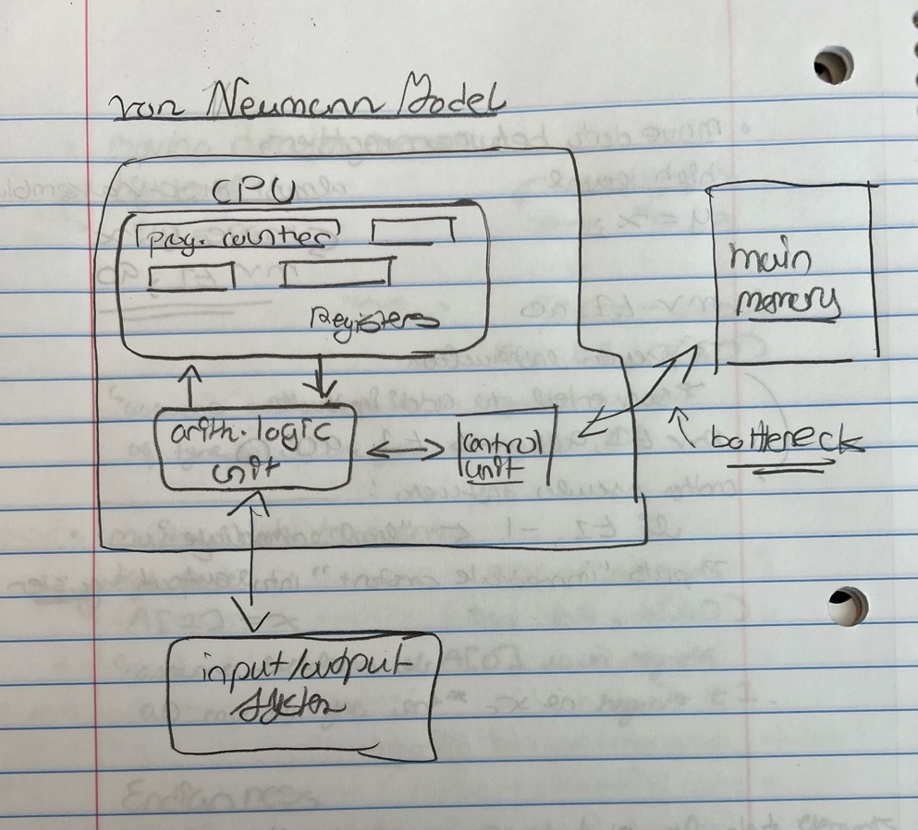
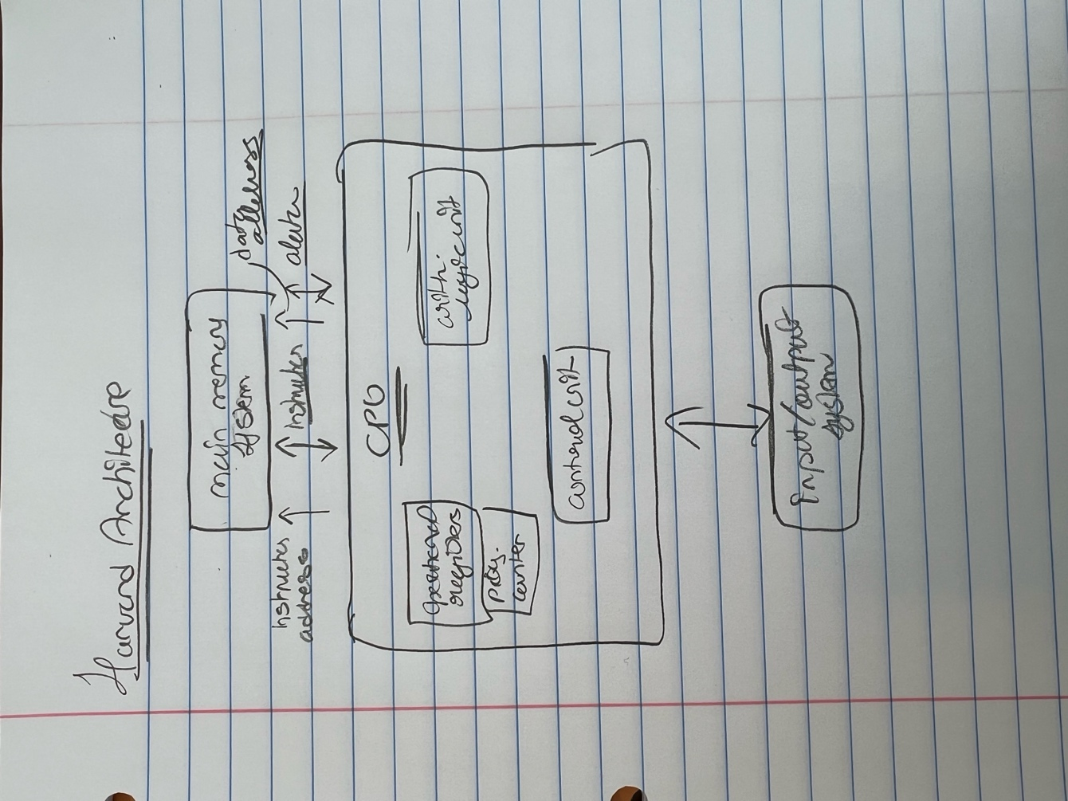
Problem 3 (7 pts)
For your laptop or desktop, or if you don’t have a computer, use one from a computer lab:
- What is it’s processor number (product name)?
  - 2021 MacBook Pro – 16 inch (Apple M1 Pro Chip)
- What is the clock speed of the processor?
  - 3.5 GHz
- How many cores does it have?
  - 0-core CPU with 8 performance cores and 2 efficiency cores
  - 16-core GPU
  - 16-core Neural Engine
  - 200GB/s memory bandwidth
- What is the capacity of the main memory (RAM)?
  - 16 GB
- What is the capacity of the hard drive?
  - 512GB
- Which I/O (input/output) devices are available? Are they input, output, or both?
  - Input: Built in keyboard, trackpad, accessibility and connectivity features. Output: Power adapters, cables, headphone jacks, multiple ports.
- What types of external I/O port are available? How many of each? Hints: You may want to check the specification of the computer provided by the Manufacturer (i.e. from its website). If you use Linux, have a look at /proc/cpuinfo and /proc/meminfo. External I/O ports are interfaces to connect I/O devices to the computer and visible from outside.
  - SDXC card slot
  - HDMI port
  - 3.5 mm headphone jack
  - MagSafe 3 port
  - Three Thunderbolt 4 (USB-C) ports with support for:
    - Charging
    - DisplayPort
    - Thunderbolt 4 (up to 40Gb/s)
    - USB 4 (up to 40Gb/s)

Problem 4 (9 pts)
Search the Internet and answer the following questions for Intel Xeon Gold 6256 Processor (33MCache, 3.60 GHz).
- What is the physical size of the package containing this chip?
  - 76.0mm x 56.5mm
- What is the manufacturing technology (in terms of nanometers)?
  - 14 nm
- How many cores does it have?
  - 12
- What is the core base clock frequency?
  - 3.60 GHz
- What is the core clock cycle time at its base frequency?
  - 3.60 GHz
- How much power does it consume on average per second when operating at its base frequency?
  - 205 W
- To install it on a motherboard, which type of socket is needed on the motherboard?
  - FCLGA3647
- What is the maximum memory frequency?
  - 2933 MHz
- What is the maximum possible memory capacity?
  - 1 TB

Problem 5 (2 pts)
Provide a description (at least a paragraph) explaining Moore’s Law.
- Moore’s Law says that transistors double every two years and performance doubles every eighteen months. This observation was made based on the growth trend seen in the semiconductor industry, which saw a consistent increase in the density of transistors on integrated circuits. This rapid growth led to drastic improvements in device performance over a rather short period of time. This law has held true for many years until recently, where as transistors get smaller and smaller, there have recent issues in other technologies not being able to keep up as well as manufacturing costs increasing.
Problem 6 (2 pts)
Two important “walls” of computer architecture are the “memory wall” and the “power wall”. Describe these walls and how they affect computer organization and design.
- The memory wall talks about the growing gap between CPU speed and RAM memory speed. As processor speeds have drastically increased, the speed at which instructions are fetched from memory hasn’t been able to keep up with the pace. In this case, the growth of processors speeds is being restricted by the RAM memory speed. It leads to a bottleneck situation in system performance where processors have to spend more time waiting for data retrieval from memory. To deal with the effects of the memory wall, modern processors use hierarchical cache systems like L1, L2, and sometimes L3 caches, providing faster access to frequently used data. This design emphasizes a hierarchy of memory levels with faster but smaller caches closer to the CPU and larger, slower main memory. This helps reduce the impact of the memory access latency. The power wall, meanwhile, talks about the challenges of managing the increasing power consumption of modern processors. Transistor counts and clock frequencies are rapidly increasing, thus leading to power consumption also increasing rapidly, which leads to issues relating to heat generation and power efficiency. People focus on creating energy-efficient architectures to address the power wall with techniques like clock gating, power gating, and dynamic voltage and frequency scaling to dynamically manage power consumption. Also, instead of relying solely on increasing clock speeds, modern processors often incorporate parallel processing architectures (multi-core or many-core) to distribute workloads and reduce power consumption per core. Use of low-power transistors and advancements in fabrication technologies also helps in achieving better power efficiency with modern technology.

